E-Leave Solution Document

*Introduction*

|  |  |
| --- | --- |
| **Application/Program** | **E-Leave Solution** |
| **Description** | 1. Employee to be able to submit the form and get approval from manager. 2. Email notifications send for approval. 3. Email notifications send to applicants once approved/rejected. |

*Intended Audience*

|  |  |
| --- | --- |
| **Audience** | **Action** |
| PLI | * Assign the technical assessment |
| Jamilah | * Perform the technical assessment |

Table of Contents

Deployment 3

1.1 Database ELeave 3

Step 1 : Create ELeave database 3

Step 2 : Create Employee table 3

Step 3 : Create LeaveApplication table 3

Step 4 : Create usp_getEmployee store procedure 3

Step 5 : Create usp_getLeaveApplication store procedure 3

Step 6 : Create usp_insert_LeaveApplication store procedure 3

Step 7 : Create usp_upd_status_LeaveApplication store procedure 3

Step 8 : Insert record in Employee table 3

1.2 Web.Config file setting 4

Step 9 : Set SMTP information to send email 4

Step 10 : Set database connection string 4

2 User Guideline 5

2.1 Leave Application Form page 5

2.2 Leave Approval page 7

# Deployment

## Database ELeave

1. Create ELeave database
2. Create Employee table

* Execute the script as attached below:-



1. Create LeaveApplication table

* Execute the script as attached below:-



1. Create usp_getEmployee store procedure

* Execute the script as attached below:-



1. Create usp_getLeaveApplication store procedure

* Execute the script as attached below:-



1. Create usp_insert_LeaveApplication store procedure

* Execute the script as attached below:-



1. Create usp_upd_status_LeaveApplication store procedure

* Execute the script as attached below:-



1. Insert record in Employee table

* Sample as below:-

|  |  |  |  |
| --- | --- | --- | --- |
| **EmployeeID** | **EmployeeName** | **SupervisorID** | **Email** |
| 1 | Jamilah | 0 | jamilahbalqish@gmail.com |
| 2 | Rifique | 1 | mohamadrifique@gmail.com |

## Web.Config file setting

1. Set SMTP information to send email

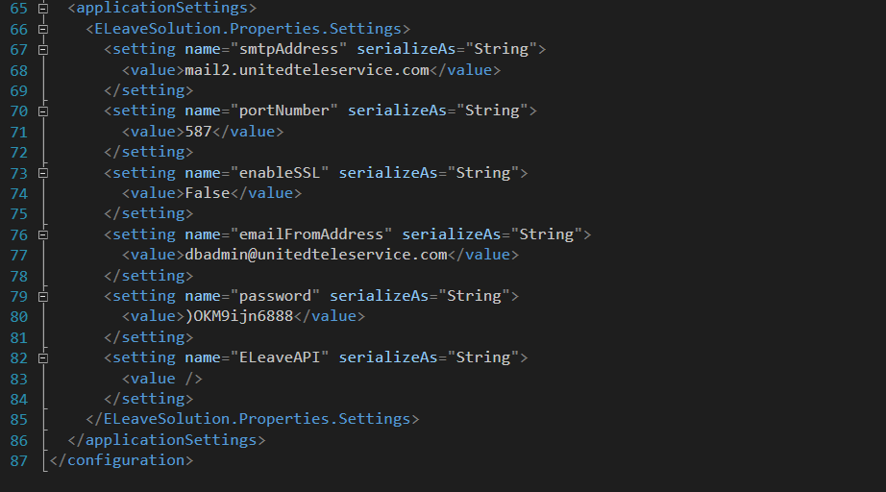

1. Set database connection string



# User Guideline

1. *This demo system has been designed by considering the system will require a User Authentication method which has not been implemented yet at the moment.*
2. *Only basic email notification content, look and feel at the moment.*

## Leave Application Form page

* At the sidebar menu, click Employee 🡪 Apply Leave.
* Leave Application Form will be shown as below: -
* The system will retrieve the employee information from database based on login information.
* *This demo has a default employee ID pre-set in the system (EmployeeID = 2)*

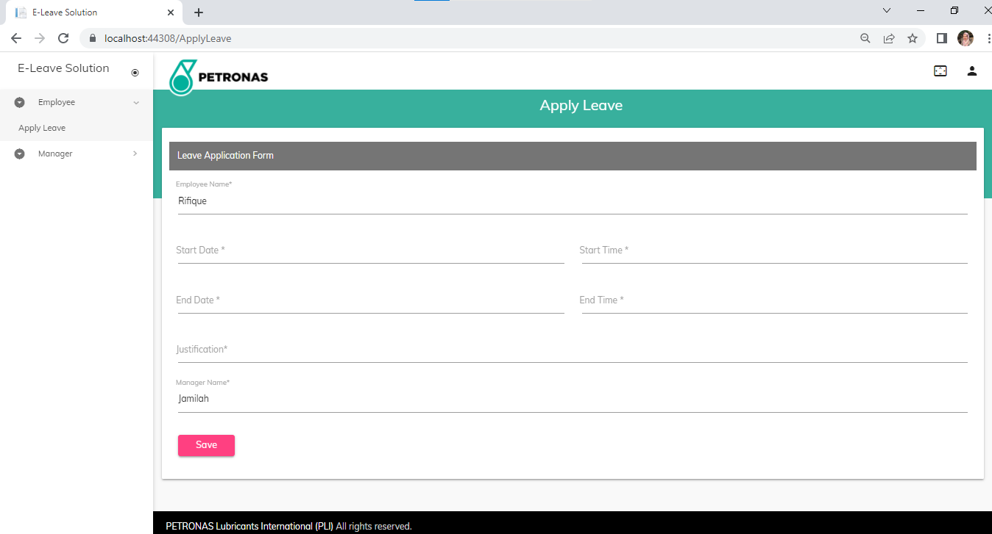

Figure : Apply Leave page

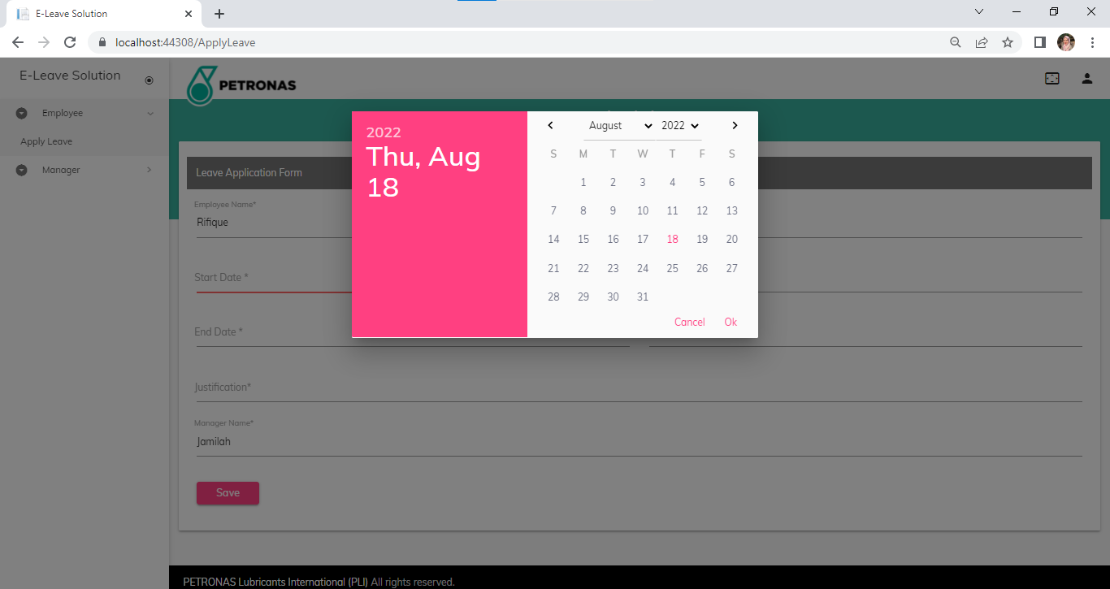

Figure : Date picker

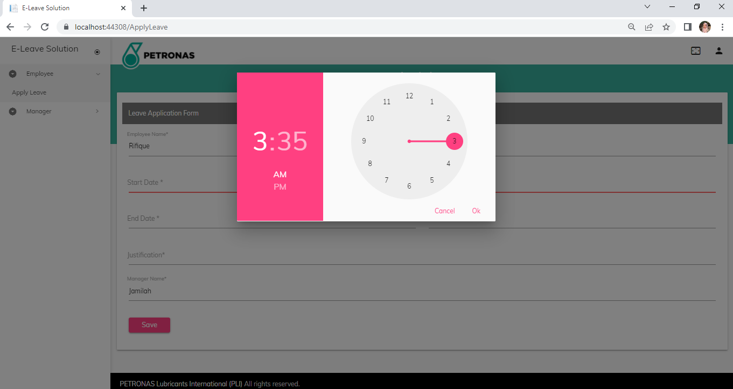

Figure : Time picker

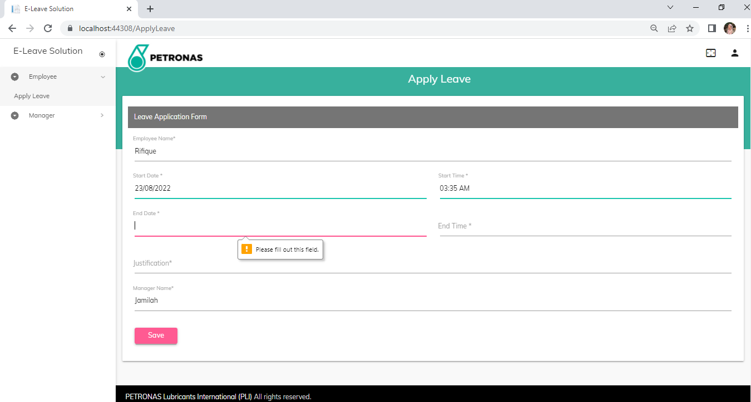

Figure : Required field validation

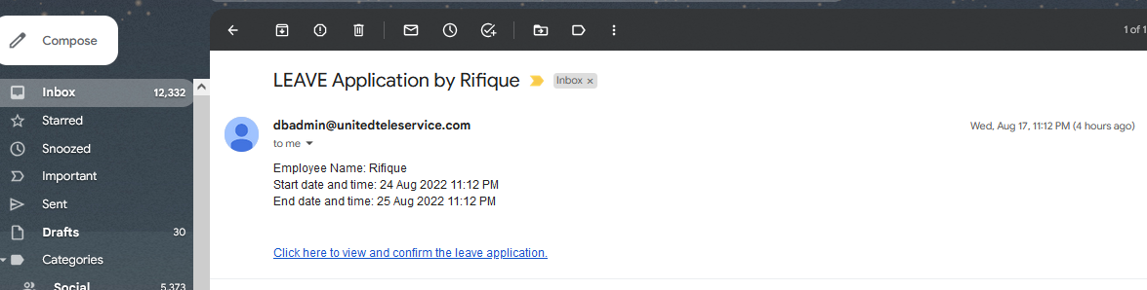

Figure : Email notification to the manager

## Leave Approval page

* By clicking at the link in the manager email, system will redirect to Leave Approval page.
* *This demo has a default LeaveApplicationID pre-set in the system (LeaveApplicationID = 1)*

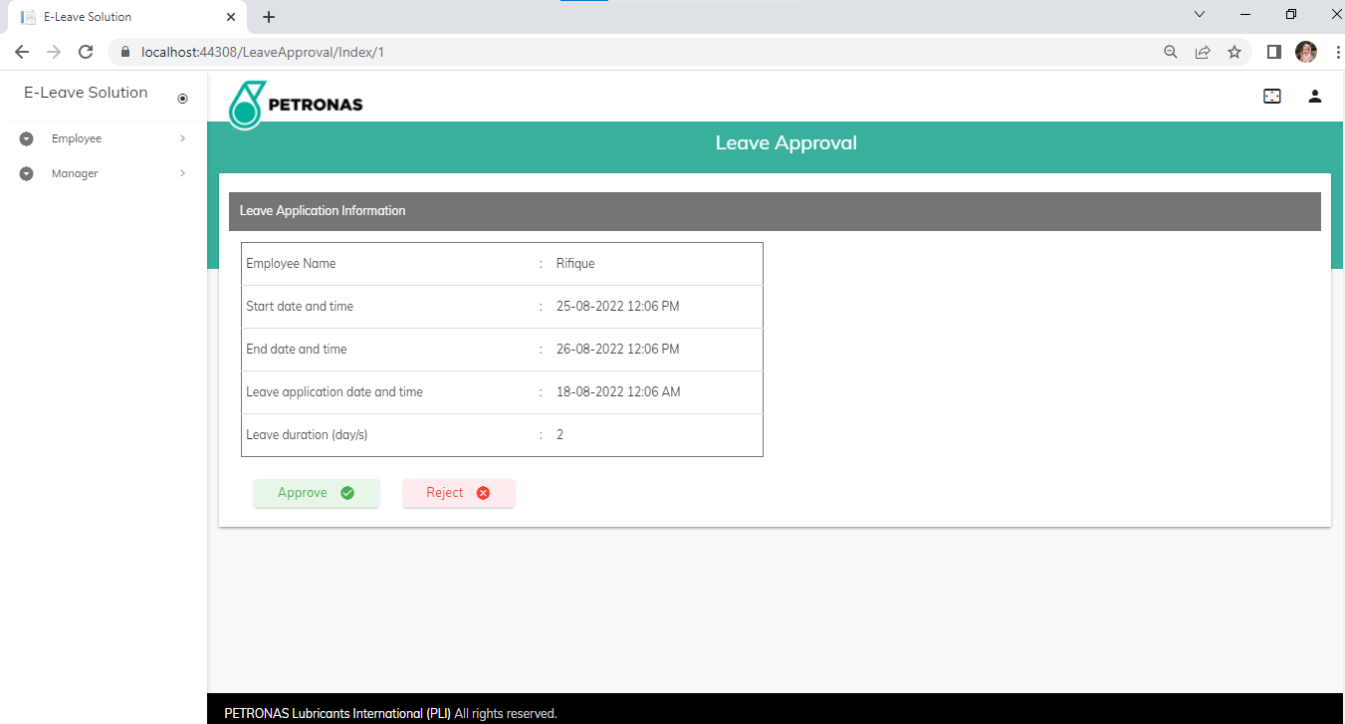

Figure : Leave Approval page

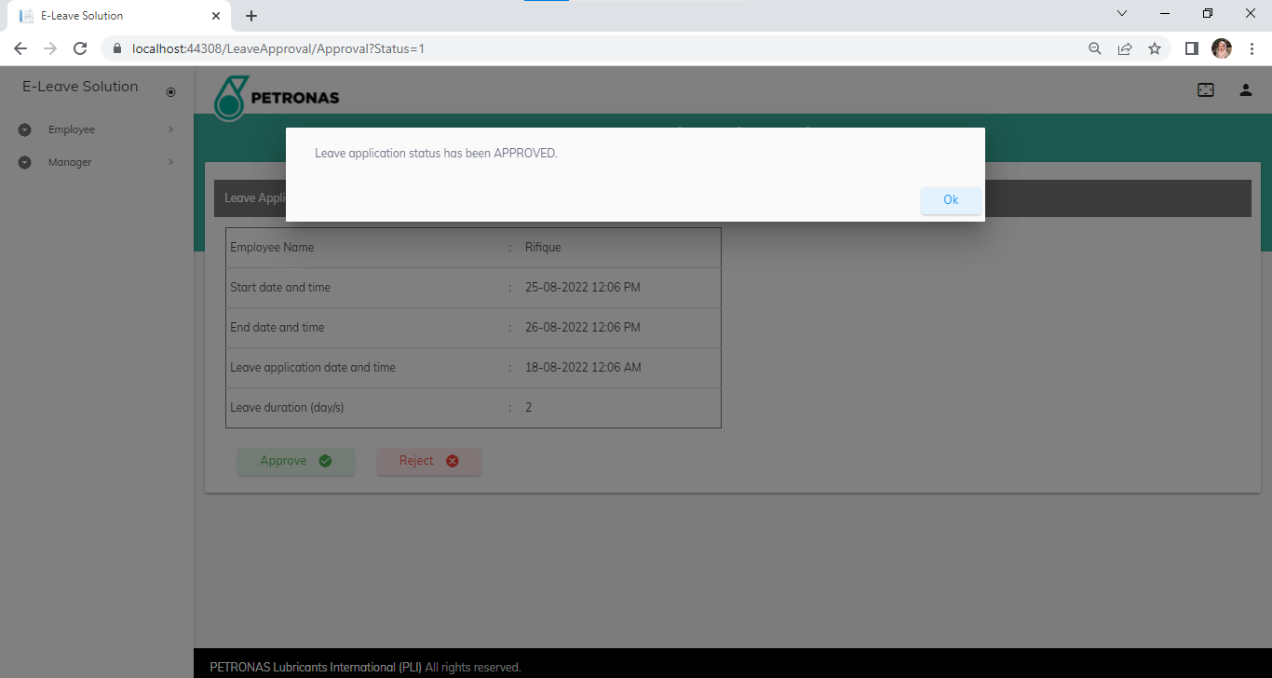

Figure : Message box once Approved/ Rejected

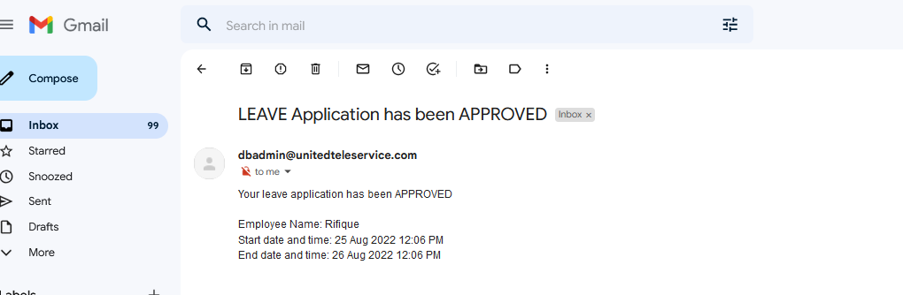

Figure : Email notification to the employee